Appreciating High Expectations Discussion Questions

Reaction Questions
Question | Notes/reflection
What resonated with you while watching the video?
What does having high expectations for students with disabilities mean to you?
Can you think of a student who has benefited from high expectations? How did that impact them?
Do you believe that all students with disabilities at our school are being held to high expectations? Why or why not?
Are there specific students or groups of students who are held to different expectations?
If you were to ask students in our school whether they believe all students are held to high expectations, what would they say?
Can you think of an instance where you may not have held a student to high expectations? What could you have done differently?

Application Questions
Question | Notes/reflection
What are we currently doing to establish high expectations for our students, including our students with disabilities?
How can our school better ensure all students, including students with disabilities, are held to high expectations?
How can we ensure that we focus on high expectations within the development and implementation of our individualized education programs?
How can we continuously learn from students about whether they feel like they are being held to high expectations?
What supports do staff need to ensure they are holding all students, including students with disabilities, to high expectations?
In your role, how might you ensure that you are holding students you work with to high expectations?

Takeaway or Next Step
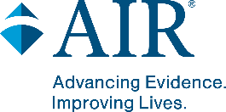
As a school community, what are our priorities and next steps in ensuring staff hold high expectations for students with disabilities? How can we more intentionally question how our beliefs and biases affect students with disabilities?
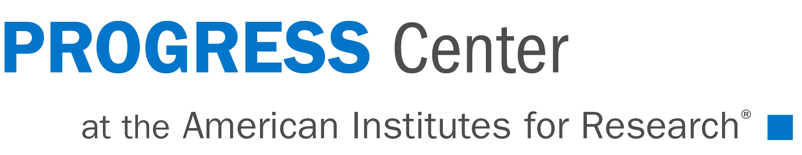
1400 Crystal Drive, 10th Floor | Arlington, VA 22202-3289
202-403-5000 | www.air.org
www.promotingprogress.org
This material was produced under the U.S. Department of Education, Office of Special Education Programs, Award No. H326C190002. David Emenheiser serves as the project officer. The views expressed herein do not necessarily represent the positions or policies of the U.S. Department of Education. No official endorsement by the U.S. Department of Education of any product, commodity, service, or enterprise mentioned in this resource is intended or should be inferred.
Notice of Trademark: “American Institutes for Research” and “AIR” are registered trademarks. All other brand, product, or company names are trademarks or registered trademarks of their respective owners.
18022_05/22

